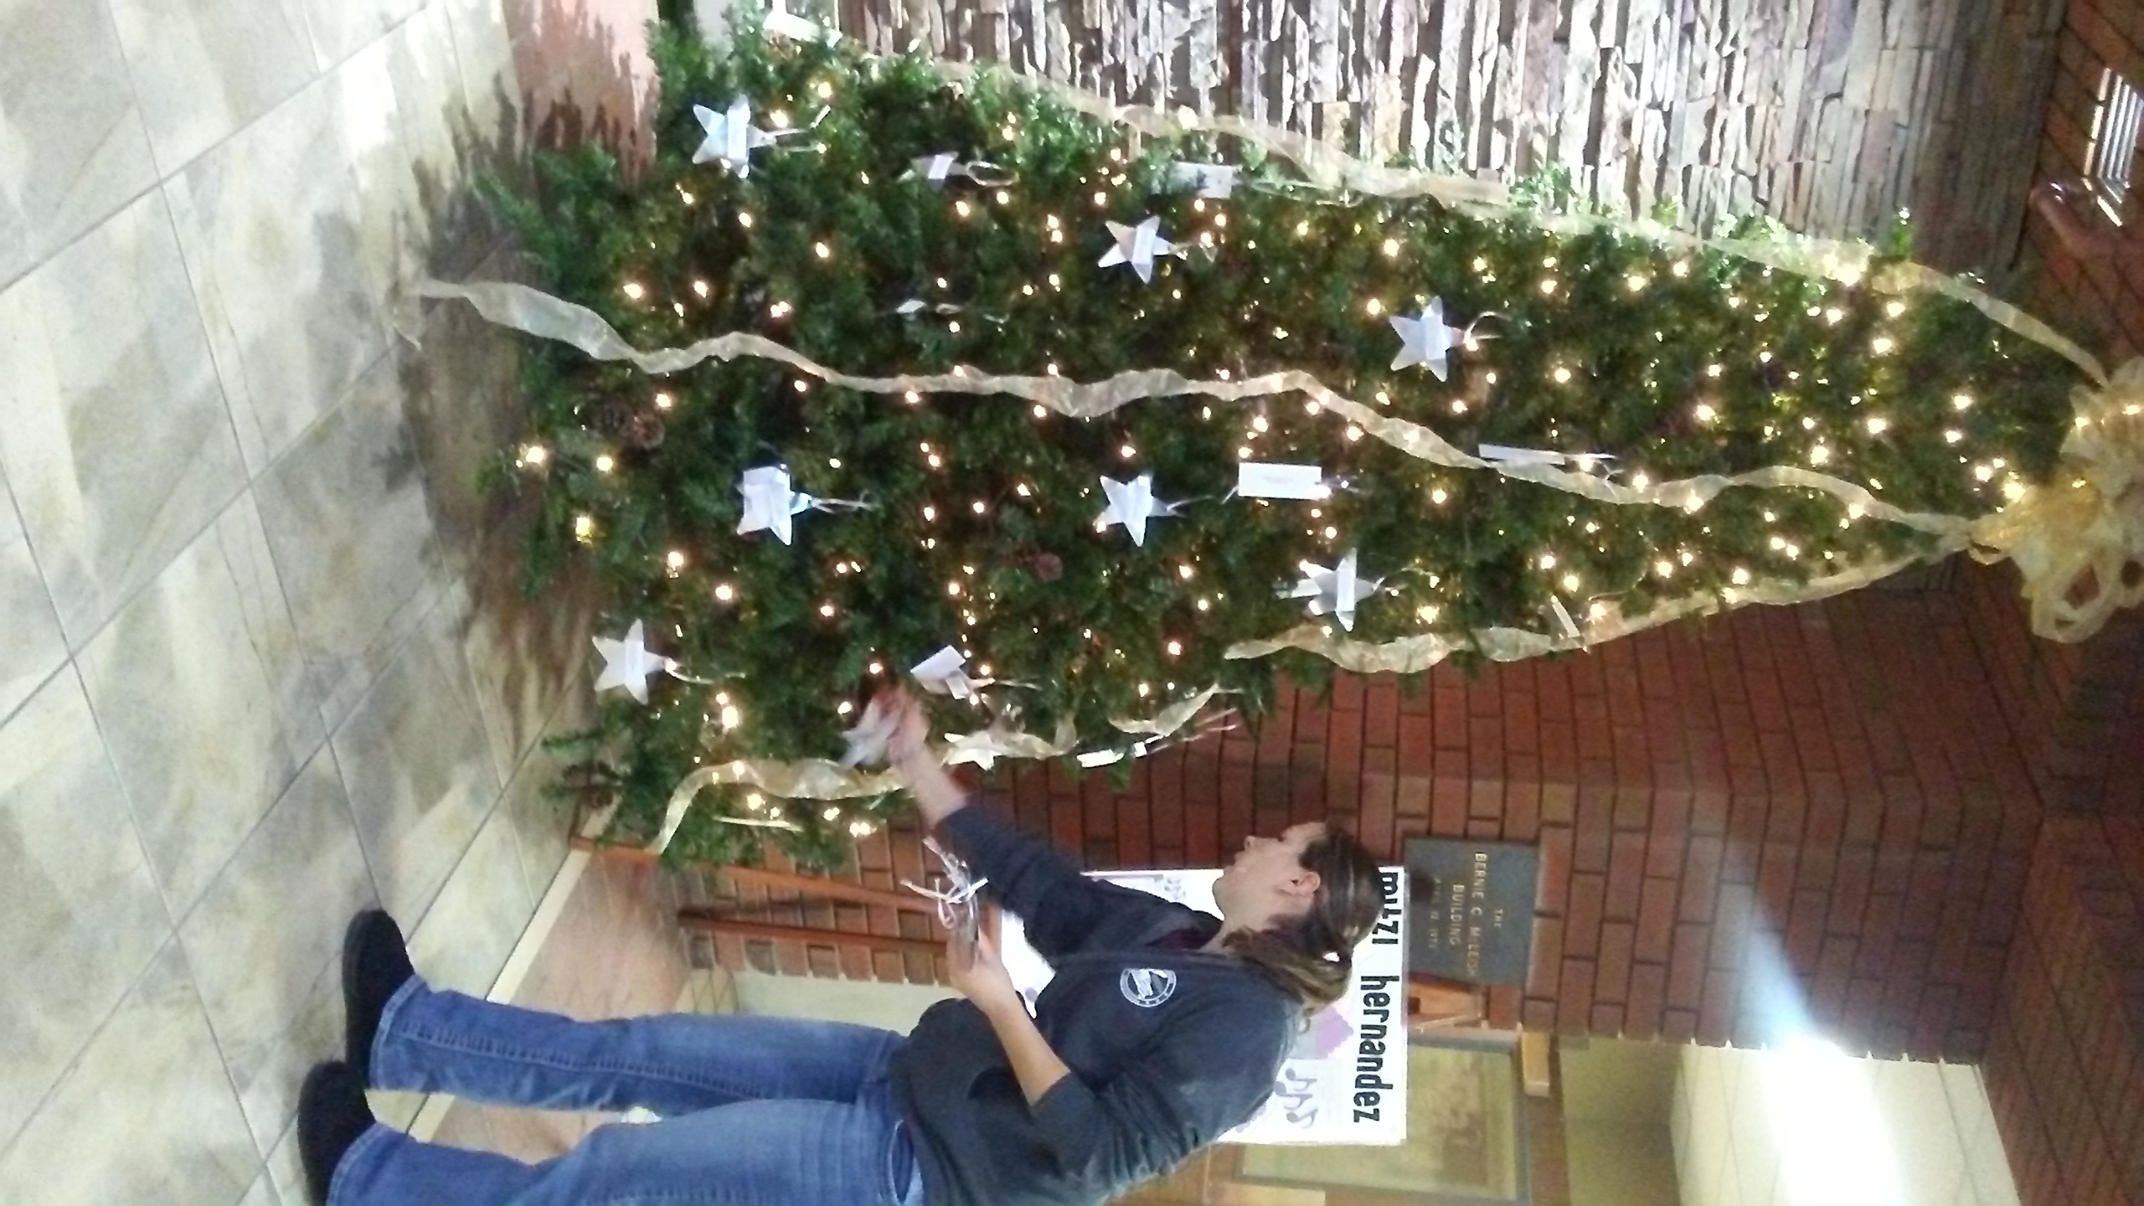

Cassie Starring the tree at GRVH
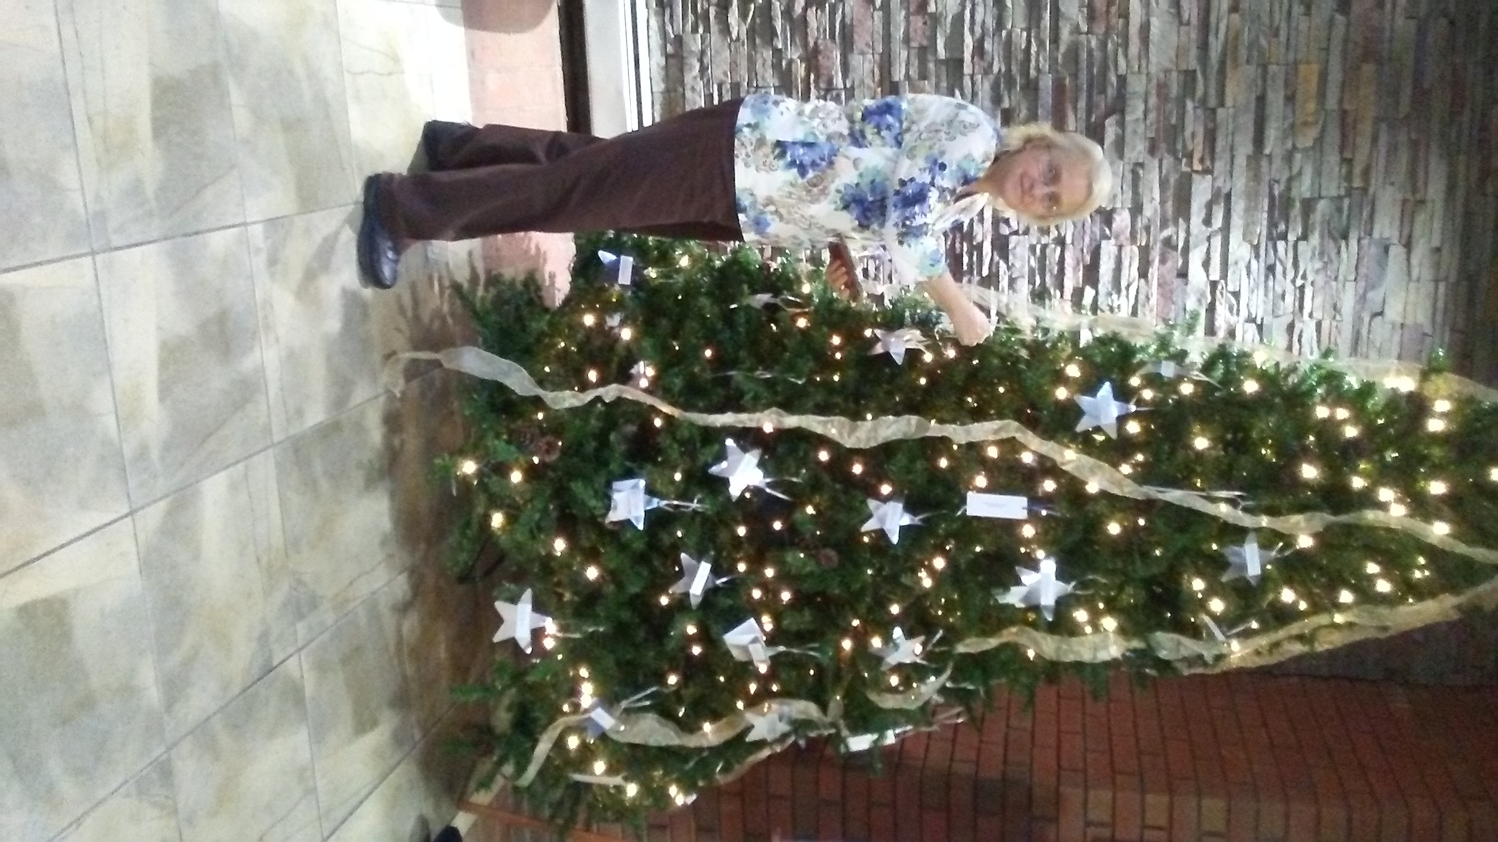

Cheryl putting stars on the tree at GRVH

